Research question 1:
In previous years, 52% of parents believed that electronics and social media was the cause of their teenager’s lack of sleep. Do more parents today believe that their teenager’s lack of sleep is caused due to electronics and social media?
Population: Parents with a teenager (age 13–18)
Parameter of Interest: p (proportion)
Null Hypothesis: p = 0.52
Alternative Hypothesis: p > 0.52 (note that this is a one-sided test)
Data: 1018 people were surveyed. 56% of those who were surveyed believe that their teenager’s lack of sleep is caused due to electronics and social media.
Task 1: Based on the above requestion question and the data surveyed, please show your computation or programming script that lead to your conclusion in favor of null hypothesis or alternative hypothesis.
Answer: For this task we have to use z-statistic test. I used proportions_ztest() function from the Statsmodels package. We know,
statsmodels.stats.proportion.proportions_ztest(count, nobs, value=None, alternative='two-sided', prop_var=False)
Here,
It is mentioned that it is one sided test so alternative will be one sided here.

The answers are (2.571067795759113, 0.005069273865860533).
The P value is .005 which is so small value which means the percentage of parents, who believe that their teenager’s lack of sleep is caused due to electronics and social media can be same as 52 % but not more than 52%.

Research question 2:
Is there a significant difference between the population proportions of parents of black children and parents of Hispanic children who report that their child has had some swimming lessons?
Populations: All parents of black children age 6–18 and all parents of Hispanic children age 6–18 Parameter of Interest: p1 — p2, where p1 = black and p2 = Hispanic
Null Hypothesis: p1 — p2 = 0
Alternative Hypothesis: p1 — p2 ≠ 0
Data: 247 Parents of Black Children. 36.8% of parents report that their child has had some swimming lessons. 308 Parents of Hispanic Children. 38.9% of parents report that their child has had some swimming lessons.
Task 2: Based on the above question and the data surveyed, please show your computation or programming script that lead to your conclusion in favor of null hypothesis or alternative hypothesis.
Answer: We have to find out the difference here. The difference in population proportion needs t-test. We can use the ttest_ind() function from Statsmodels.
Here, Parents_count1 = 247, Parents_count2 = 308, Hypothesis1 = .37, Hypothesis2 = .39.
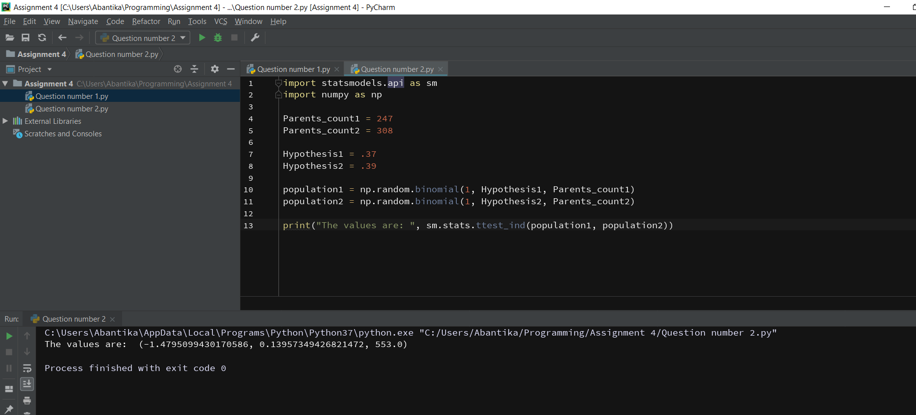
The answers are (-1.4795099430170586, 0.13957349426821472, 553.0)

Research Question 3:
Let’s say a cartwheeling competition was organized for some adults. The data looks like following,
(80.57, 98.96, 85.28, 83.83, 69.94, 89.59, 91.09, 66.25, 91.21, 82.7 , 73.54, 81.99, 54.01, 82.89, 75.88, 98.32, 107.2 , 85.53, 79.08, 84.3 , 89.32, 86.35, 78.98, 92.26, 87.01)
Is the average cartwheel distance (in inches) for adults more than 80 inches?
Population: All adults Parameter of Interest: μ, the population mean cartwheel distance.
Null Hypothesis: μ = 80
Alternative Hypothesis: μ > 80
Task 3: Based on the above requestion question and the data, please show your computation or programming script that lead to your conclusion in favor of null hypothesis or alternative hypothesis.
Answer:
I will use the z-test from StatsmodelsData for this task.
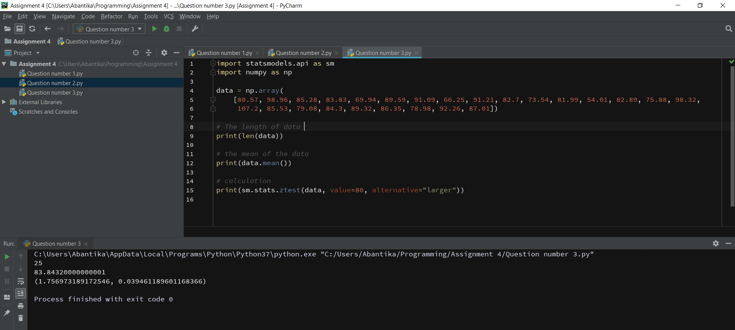
We can see that the mean is 83.84 and σ is 10.72 here.
The p-value is 0.0394 here and it is lower than the standard confidence level 0.05, we can reject the Null hypothesis that the mean cartwheel distance for adults is equal to 80 inches.

